**Construct species phylogenic tree for *Saccharomyces sensu stricto* using BUSCO genes**

**Jing Li**

1. **Introduction**

Phylogenic relationship is very important when we research on gene origin or some other evolutionary questions. Currently, we have eight Saccharomyces species, S. cerevisiae, S. paradoxus, S. mikatae, S. kudriavzeii, S. arboricolus, S. uravum, S.bayanus, and S. eubayanus, with good assembly genomes. However, their phylogenic relationship is not clear. Different papers present different phylogenic tree for *Saccharomyces sensu stricto* species. In addition, many species within the Saccharomyces sensu stricto clade have been found to hybridize with other species, and usually has chromosomal loss, replacement, or rearrangement within the hybrid genetic lines. S.bayanus is an example from S. cerevisiae, S. uravum, and S. eubayanus (Pérez-Través et al., 2014). But we don’t know its genome is more similar as which parent.

BUSCO, also known as assessing genome assembly and annotation completeness with Benchmarking Universal Single-Copy Orthologs (Robert et al., 2017). It provides all the ancient or common gene orthologs in fungi. We could extract the ancient genes from each species genome using BUSCO.

Our objective is that construct a species phylogenic tree from all the BUSCO gene trees. Then compare to the current paper, to verify how the species phylogenic tree from BUSCO genes close to other research.

1. **Method**
2. **Data collection**

Collect all the genome sequence of these eight *Saccharomyces sensu stricto* species from NCBI database. Collect all the BUSCO orthologs dataset for fungi from BUSCO web.

1. **Predict conserved genes**

Predict fungi conserved genes in eight *Saccharomyces* species through BUSCO software. BUSCO map the fungi conserved gene dataset to the genome and then predict the conserved gene and protein sequence for each species.

1. **Gene alignment**

Extract all the conserved genes for each species, and then do multiple sequence alignment with protein sequence among these eight species by guidance using MAFFT algorithm.

1. **Gene tree construction**

Construct gene trees for each antient gene with maximum likelihood approach using RAxML program. Using JTT model with 100 replicates bootstrap analysis to search for the best-scoring ML tree.

1. **Species tree construction**

Combine all the gene trees and then generate a species tree using the ASTRAL coalescent-based species tree estimation program.

1. **Results**
2. **BUSCO result**

The total amount of fungi ancient genes is 1,662 in *Saccharomyces* *sensu stricto*. However, not every ancient gene in all eight species since not completed genome assembly, or lost in the evolution history. Hence, only 1,223 genes exist in all eight species. Figure 1 shows the proportion of the existing or missing ancient genes in each genome.

1. **ML gene trees**

The maximum likelihood gene trees are analyzed by RAxML using JTT model with 100 bootstrap replicates. In the 1,662 best score ML trees, the maximum likelihood is range from -9642.5 to -324.0. The distribution is right skewed, which means most gene trees have high maximum likelihood. Figure 2 shows the distribution of the maximum likelihood in each best core gene trees. Exploring the 1,223 gene trees with all species, we found 38 different types topological trees. Some gene trees only include 1 gene, the most common gene tree include 470 genes. All the gene trees are shown in the supplemental material.

1. **ASTRAL species tree**

ASTRAL is statically consistent under the multi-species coalescent model, and is useful for handling incomplete lineage sorting. We combine the 1,662 gene trees together, and the obtain a species tree from ASTRAL, which is shown in figure 3.

1. **Discussion**

From RAxML maximum likelihood analysis, we get 38 different topological trees. Comparing our gene trees to the final species tree, no single gene tree has the same topological shape as the species tree. The most common gene tree is only account for about 30% of all genes, that is maybe the reason why our final species tree is different from all the gene trees. However, these gene trees and species tree still have some common part. For example, in species tree and most gene tree, the relation between S. cerevisiae and S. paradoxus are closed than other, which also find between S. uravum, S. bayanus. We can also speculate the gene emergence, change or lost according each gene trees.

In these eight species, only S. bayanus is a hybrid, which is also known as Saccharomyces bayanus var. bayanus. The species tree shows that it is more closed to S. uravum (Saccharomyces bayanus var. uravum). S. bayanus should inherit more genes from S. uravum than other two species. Moreover, S. bayanus may only got a small part of gene from S. cerevisiae, since their distance is larger than other two species.

There is no paper shows the phylogenic relation among all eight species, but some papers showed the phylogenic tree for seven species except S. bayanus (Borneman et al., 2015). The species tree is a little different with our result, which is shown in figure 4. In this paper, S. eubayanus and S. uravum are in the same clade which is in the same hierarchical level as another clade with other 5 species. However, our result shows that S. eubayanus is the most ancient species among these 7 species, and then is S. uvarum (except S. bayanus). S. eubayanus and S. uravum are not in the same clade. But the relation among other species are the same. One possible reason is that we use protein sequence for this study, not nucleotide sequence. Protein sequence is more flexible in the alignment because of the degeneracy of codons.

In conclusion, we can better understand the phylogenic relation in Saccharomyces sensu stricto through both the gene trees and species tree. Furthermore, we can explore the gene evolutional way for some specific genes, such as orphan genes.

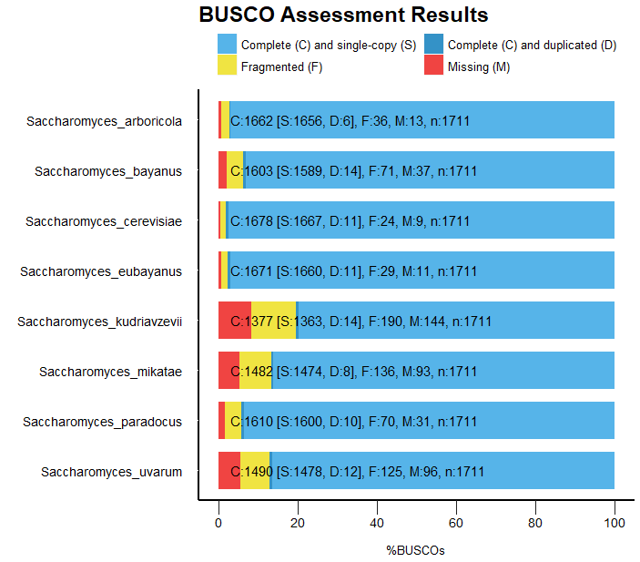**Figure 1. BUSCO analysis for eight genomes.**

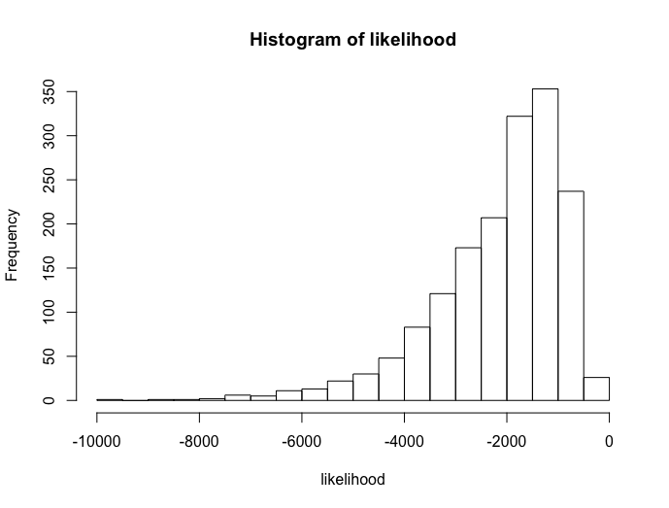

**Figure 2. Histogram of likelihood for 1,662 best scoring ML gene trees.**

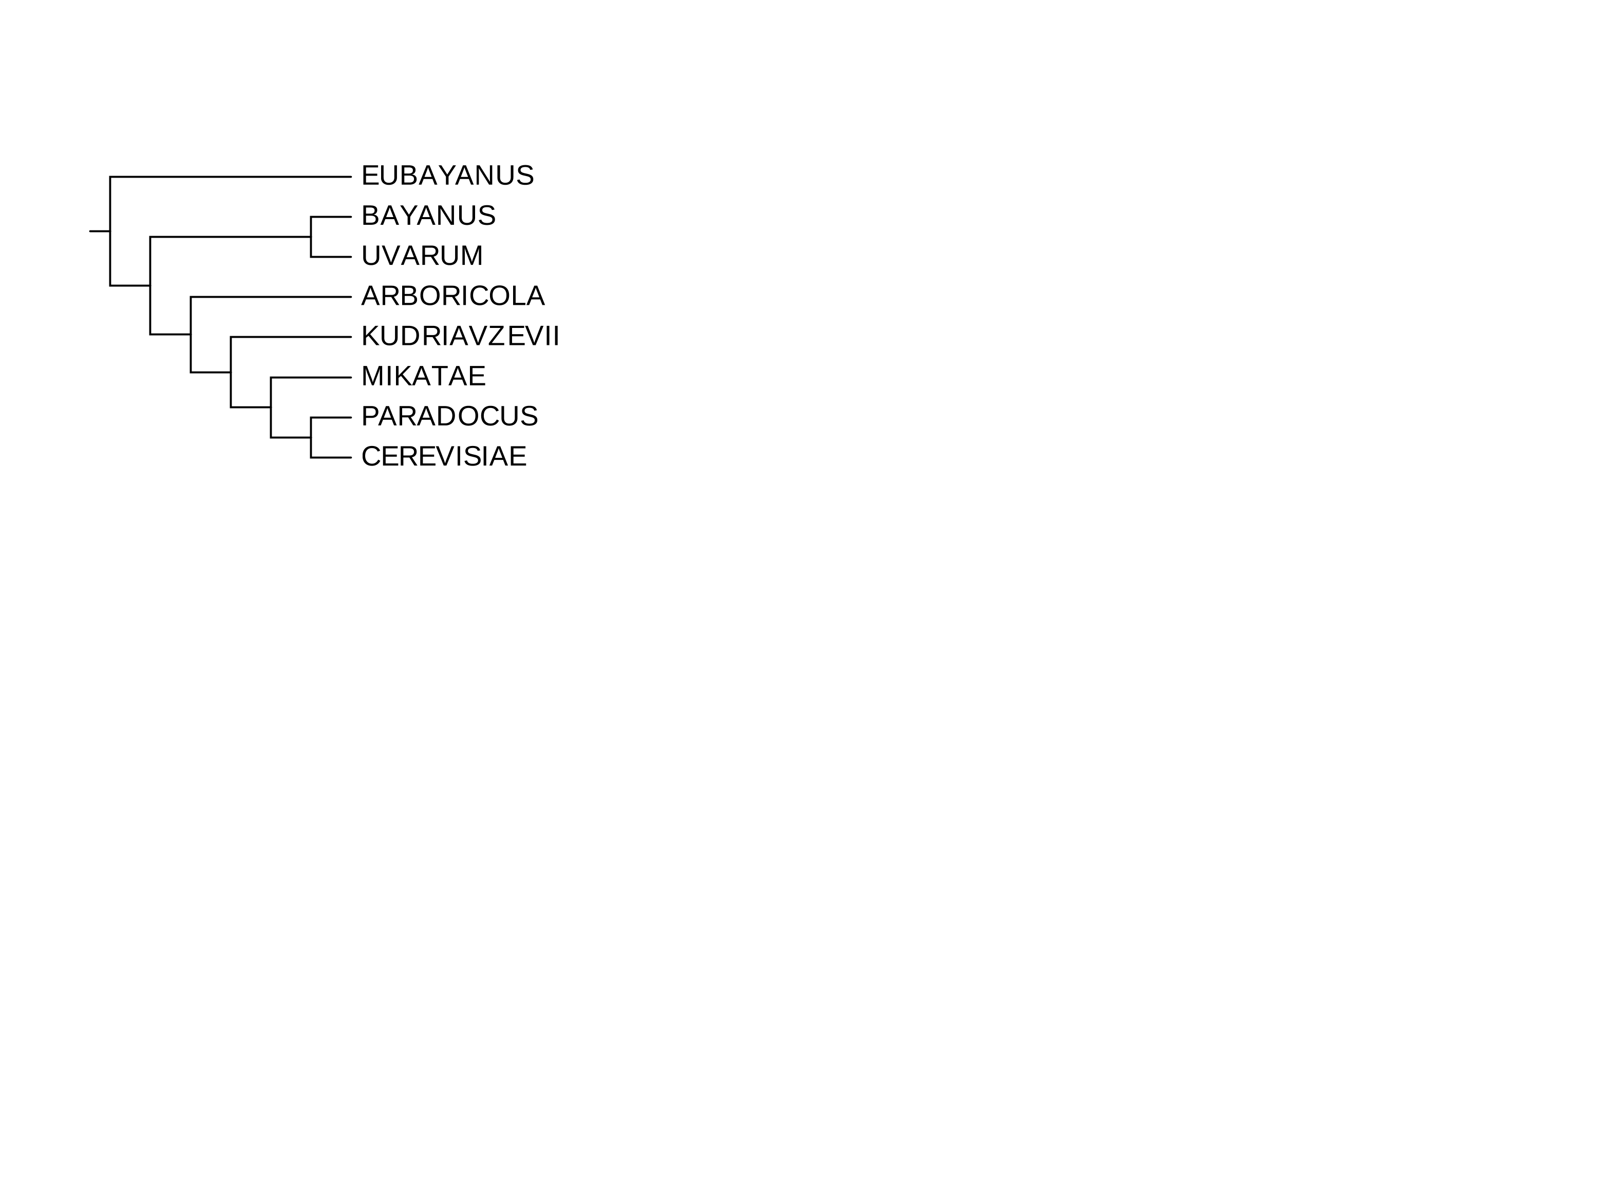

**Figure 3. ASTRAL species tree for 8 species in Saccharomyces sensu stricto.**

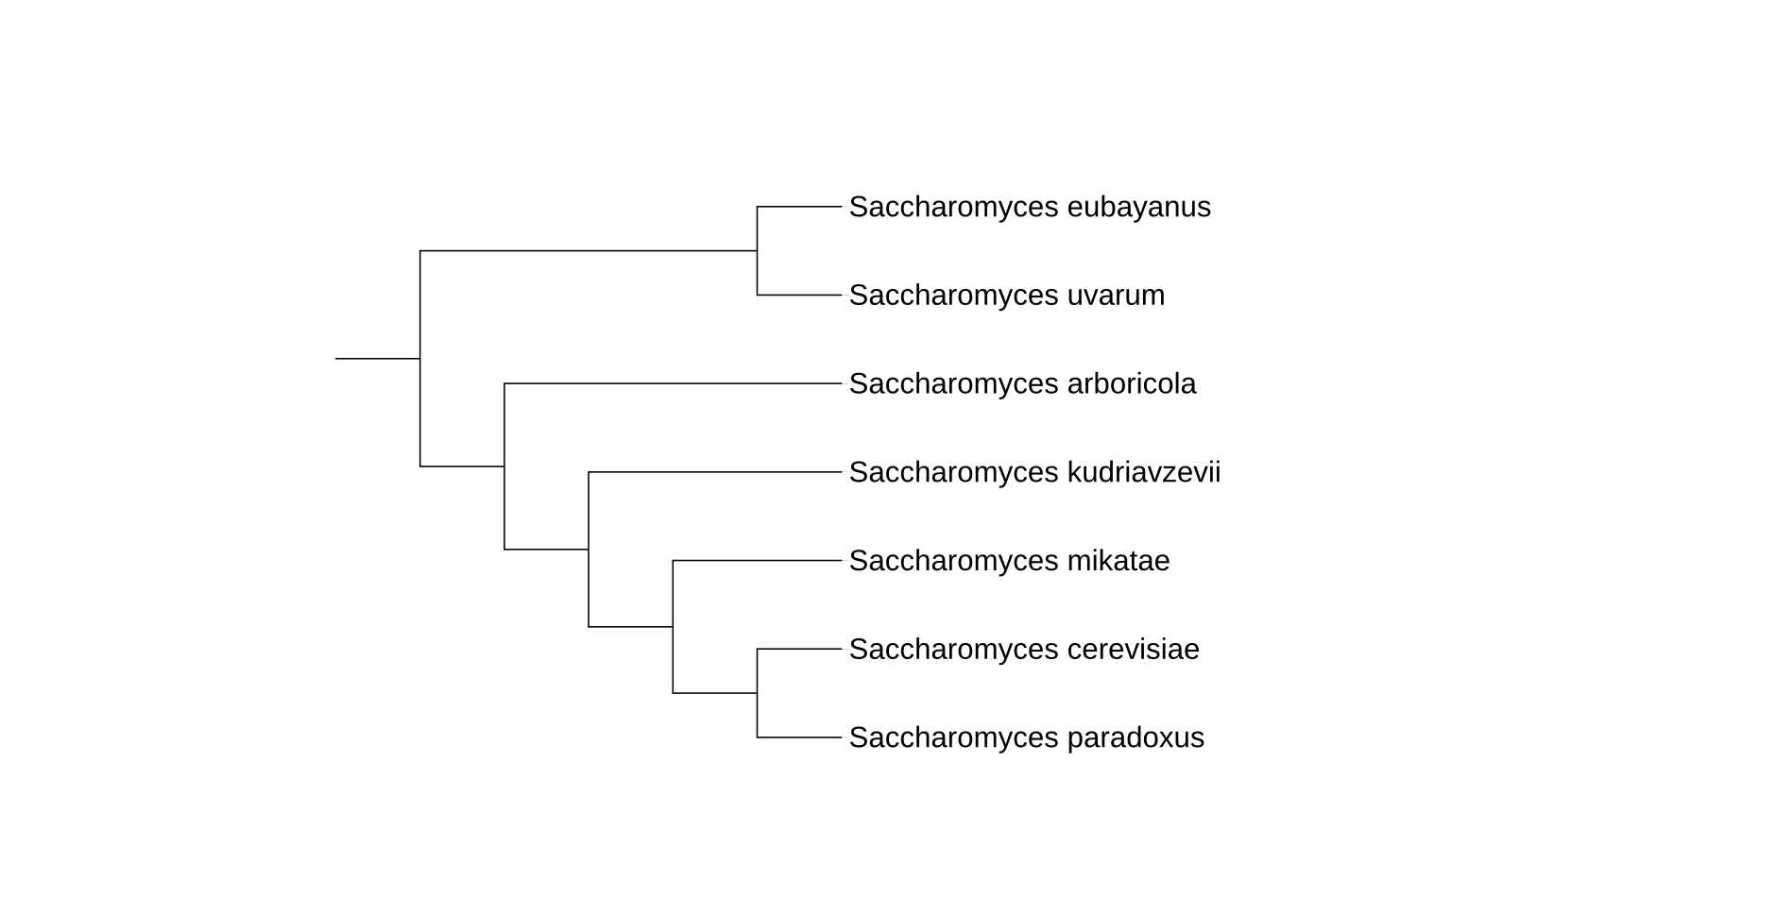

**Figure 4. Species tree for 7 species in Saccharomyces sensu stricto from Borneman et al., 2015.**

1. **Reference**

Borneman, Anthony R., and Isak S. Pretorius. "Genomic insights into the Saccharomyces sensu stricto complex." Genetics 199.2 (2015): 281-291.

Pérez-Través, Laura, et al. "On the complexity of the Saccharomyces bayanus taxon: hybridization and potential hybrid speciation." PLoS One 9.4 (2014): e93729.

Waterhouse, Robert M., et al. "BUSCO applications from quality assessments to gene prediction and phylogenomics." Molecular biology and evolution 35.3 (2017): 543-548.